Replacing the 1961 to 1963 Shift Detent and Shift Lever
Tom Gugliotta
VTCI Member #9624
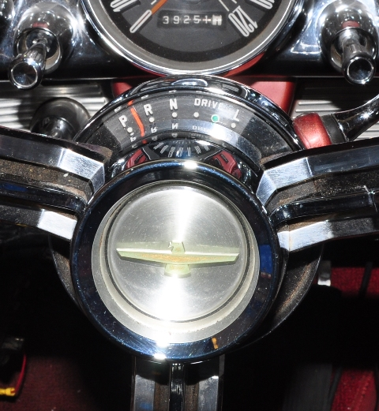This topic was covered for Squarebirds at this link. However, as I proceeded to do this, I noticed a few differences between the 58 to 60 and the 61 to 63. This procedure includes replacing the shift lever and detent. Save yourself a lot of trouble and replace them both at the same time. In my case, the shift lever was the cause of my problem. The Squarebird article also doesn't mention any snafus that you might run into, of which I ran into several. Below you can see my shifter is ready to jump into reverse and the car won't start unless I press up on the shifter.

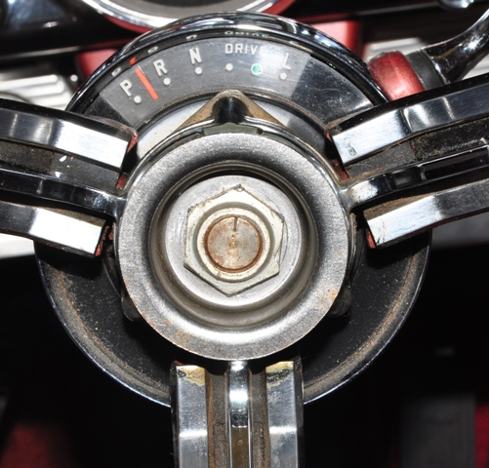Pull off the trim cap and remove the nut with a 15/16" socket and 6" extension.

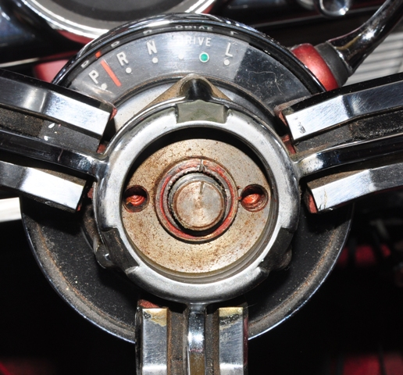Notice the shaft is already scribed whereas the Squarebird shaft was not.

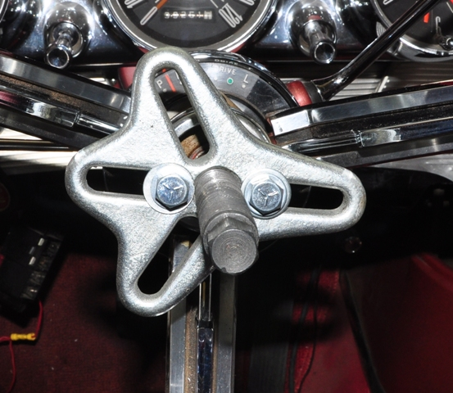The bolts to use for the puller are 5/16"-24. It comes off with minimal effort.

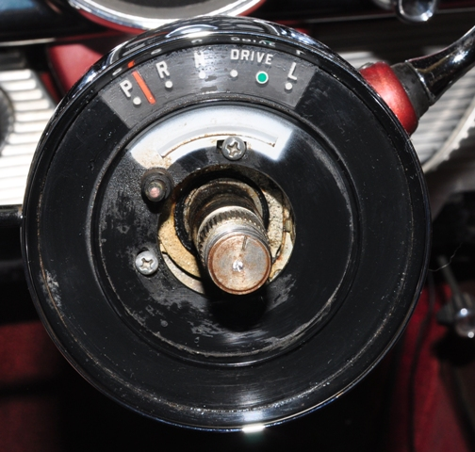Pull the horn contact out and the two drive indicator plate screws and set them aside with all your other parts. You'll have a lot of small stuff to keep track of. I used a magnetic tray.

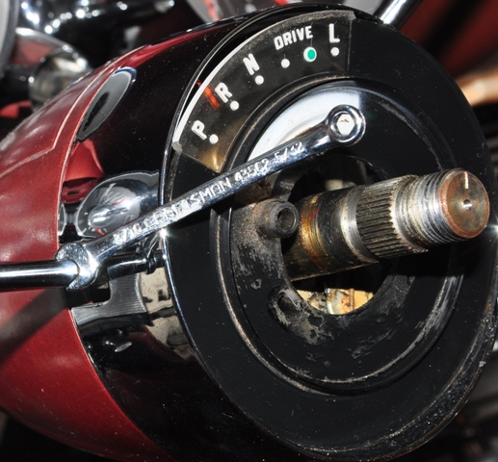I used a 3/16" ignition wrench to remove the turn signal lever to avoid damaging it. A small crescent wrench will probably also work if you don’t have an ignition wrench. It is not difficult to remove.

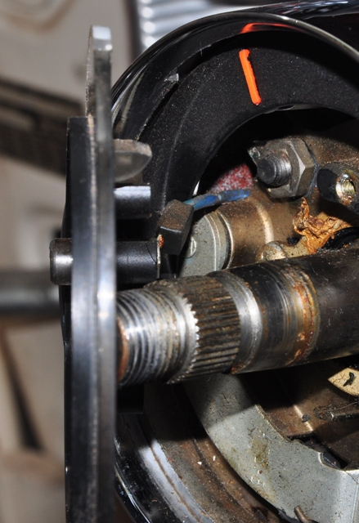This was the first problem I ran into. There was no slack in the horn wire. After pondering for awhile, I looked for the blue/yellow stripe wire at the base of the steering column. While pushing on it a bit to give it slack, I gently pulled the wire until I had enough slack to work.

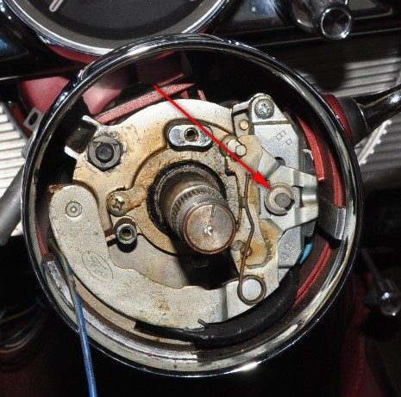The canceller is retained by a horseshoe nut and spring on a small nylon shaft. Slide the nut off very carefully, keeping a finger on the post to prevent the spring from flying into oblivion. This will be the most confounding part of the whole procedure. Reassembly was next to impossible for me, however after losing and re-finding the parts multiple times, I finally got it back together.

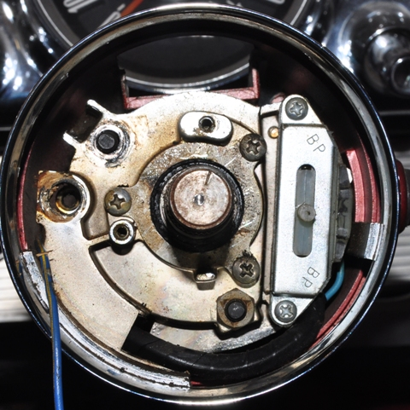Pull the canceller lever out. Now the nut at 5 o'clock is visible. Don't remove it yet though, and actuall leave the one at 10 o'clock in for now because there was another surprise.

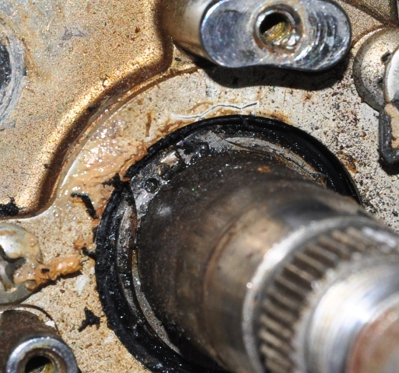The surprise was this snap ring on the steering shaft. I had a pair of snap-ring pliers, but it still proved challenging to remove. It goes back on with no problem of course.

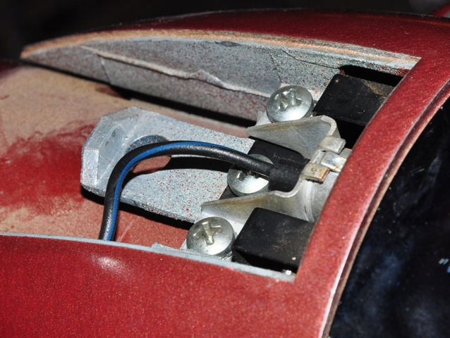Remove the cover panel with a tape covered screwdriver. Remove the three screws holding the shift indicator light and black background piece in place. Pull the black background piece out from the front and set the light aside.

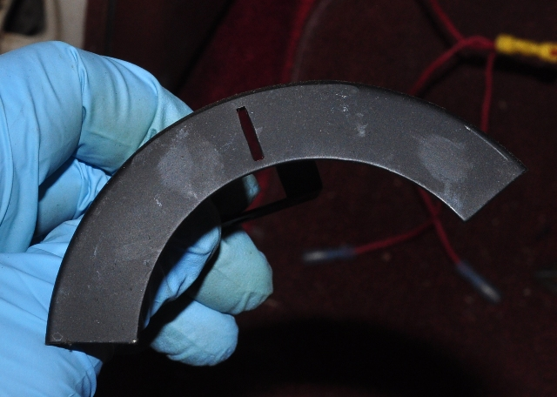The background plate is easy to smudge up, but I cleaned it with a little denatured alcohol before reinstalling it. Rubbing alcohol or window cleaner would also work. Don’t use any harsh solvents such as lacquer thinner or paint thinner.

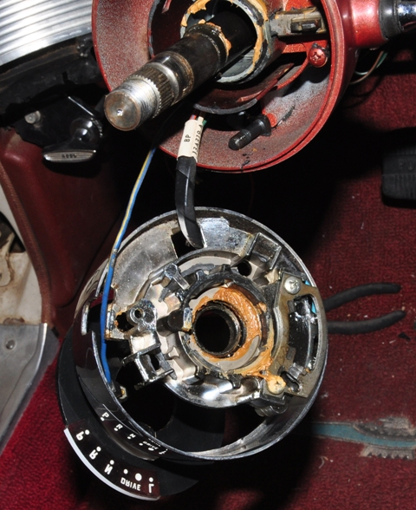Finally, the detent plate and shift lever are in sight. Notice one of the black retaining bolts in the steering column. This was addressed in the Squarebird article, but I'll discuss it again as it proves tricky during installation

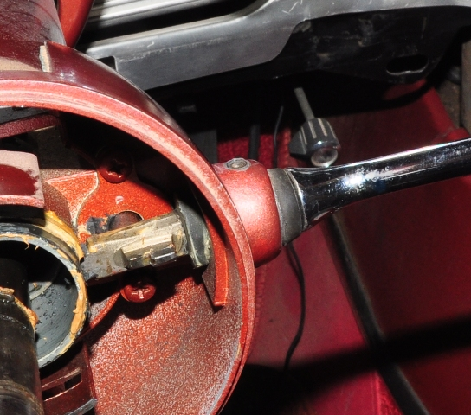The spring and nut was frustrating enough, now this pin retaining the shift lever has to come out without destroying anything. I moved the shifter to low and drove it out with a large nailset. It took a lot of force to get it going, but once it started moving it slid out without too much force. Nevertheless, it was nerve racking to remove.

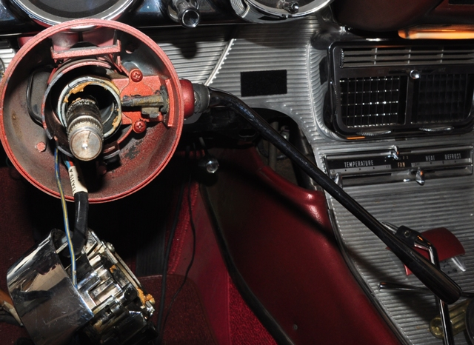To remove the shifter, rotate it 90 degrees down to free it from the rear pressure pin. It then pulls out easily. Just reverse the process when installing the new shifter. If the rubber binds up during installation, smear a small dab of petroleum jelly on it and it will slide in easily. Driving the pin back in is also a challenge, but it goes in with some powerful but careful hammering with a center punch or large nailset.

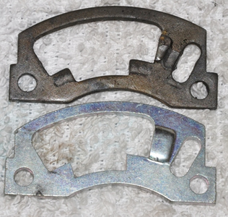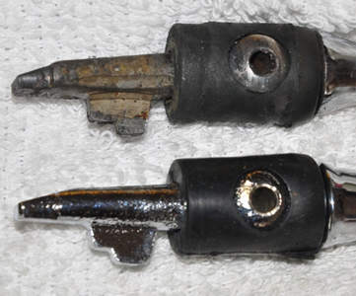Comparison of the old and new parts. The reproductions both look improved in design.

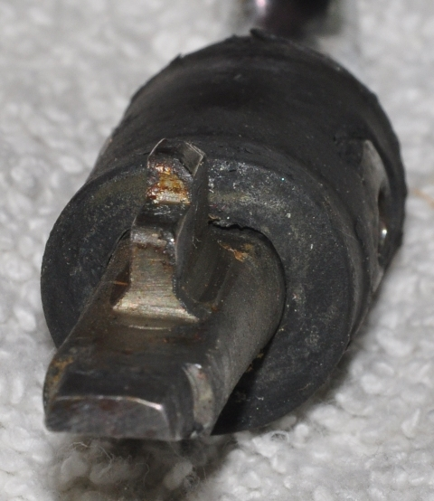Here is my problem. The edge has chamfered on the shift lever. This thing was a time-bomb, ready to fall into reverse.

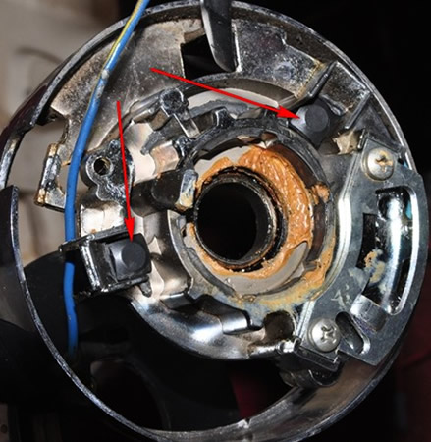During reassembly, put the retaining bolts in the back, and in the front, thread the nuts on a couple turns.

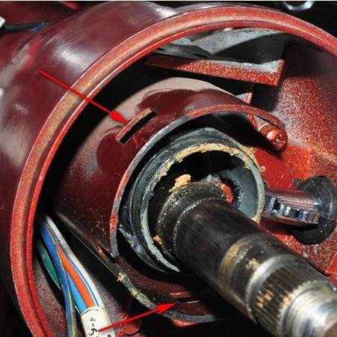Then, using a thumb on each nut, push them outward until the whole assembly snaps back into place and the square bolt heads are engaged into the outside of the slots shown..

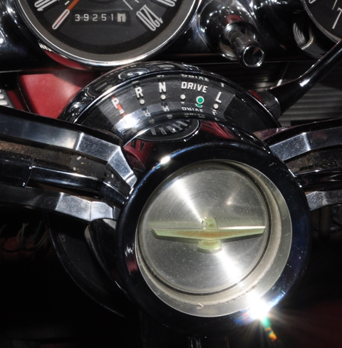Now, once you get that spring and horseshoe back on, you're home-free with a nice tight shifter. It's actually in park now and feels like it will stay there. The indicator plate is adjustable, so place the shifter in park, line up the plate, and tighten the screws before replacing the steering wheel.

